Banker’s Algorithm
- The Need Matrix
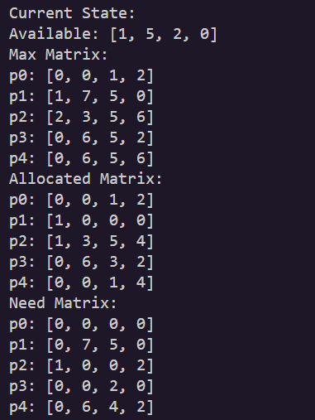
- In order to enter the safe state, print the sequence of processes which satisfy the safety criteria.
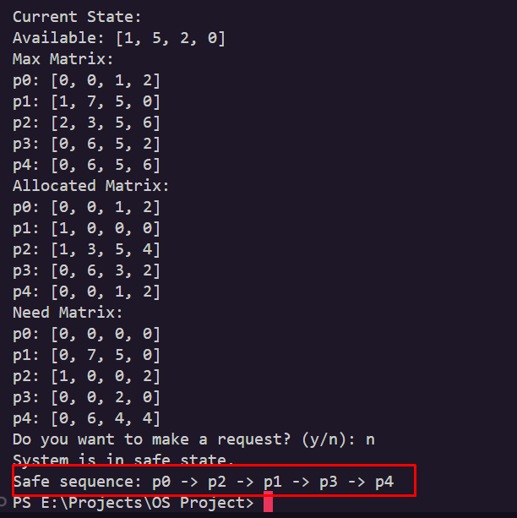
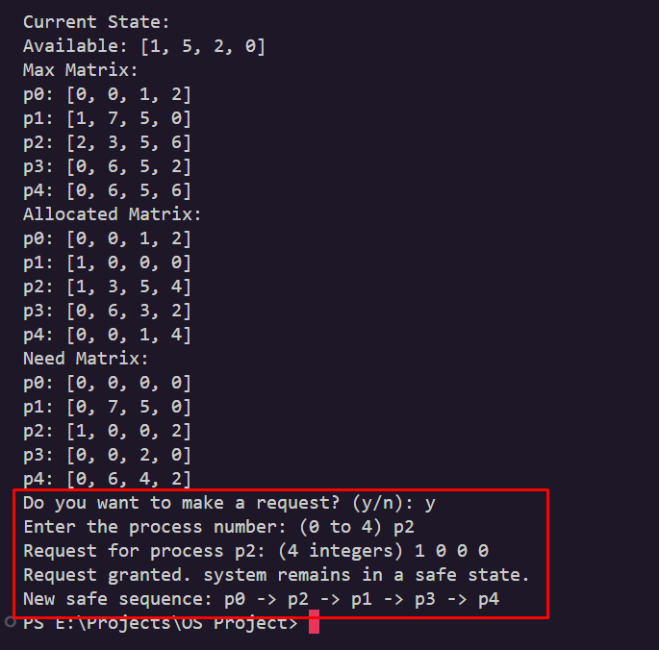
- Ask the user if a request can be granted or not. If yes, show the changes in the matrices if any.

